**Project 1**

DS-B

17L-4240 Mohammad Mannan Akmal  
17L-4328 Zaeem Riaz  
17L-4347 Usman Khan Lodhi

**Original Images**

**Pak CNIC**

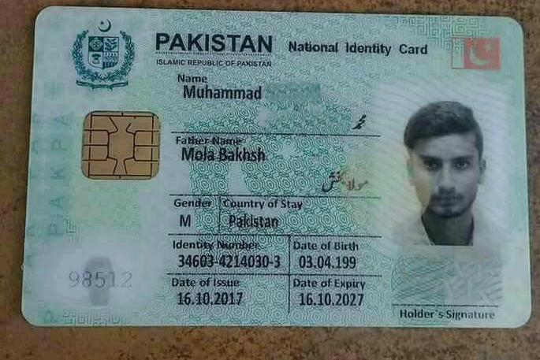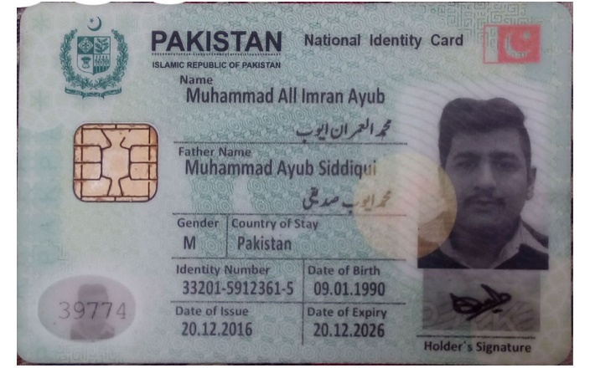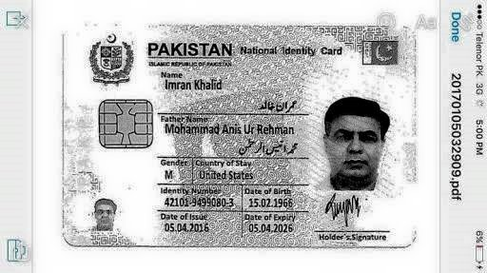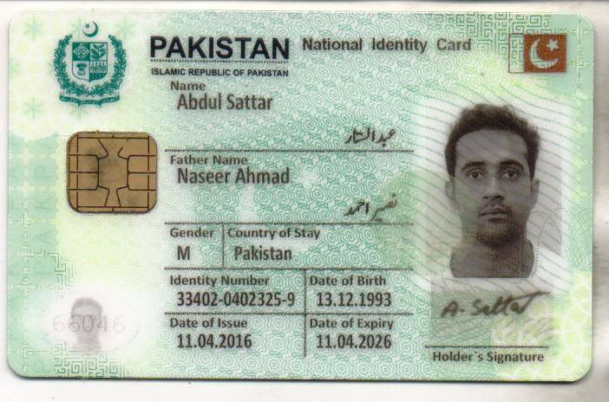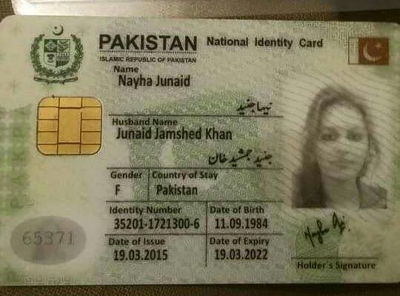

**UK License**

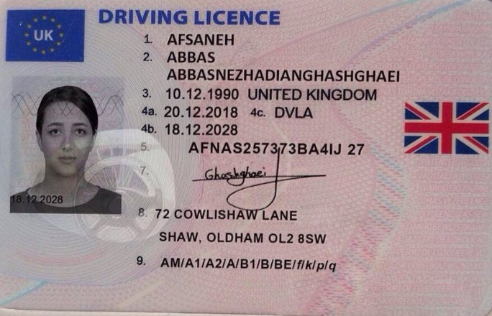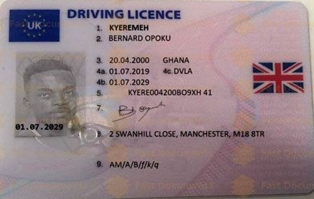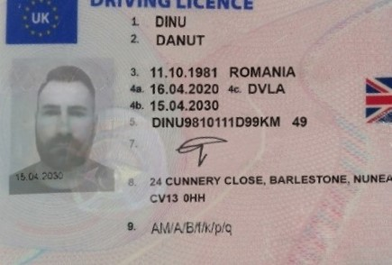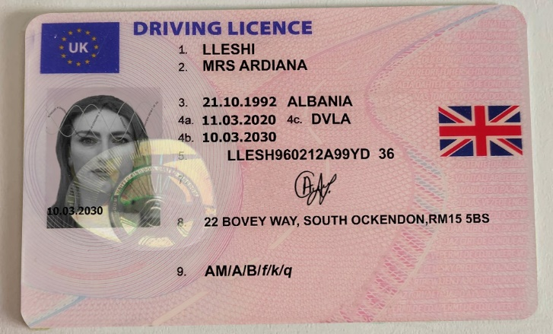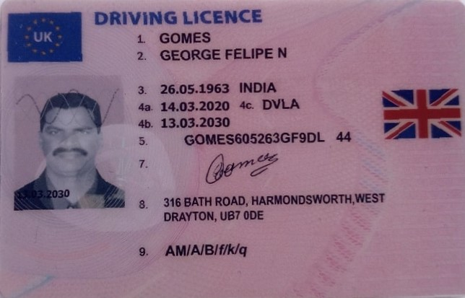

**Annotated Images**

**Pak CNIC**

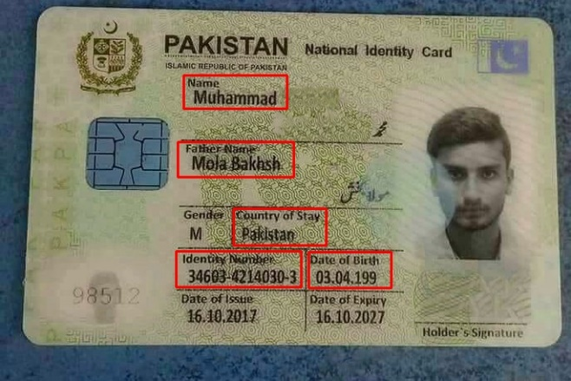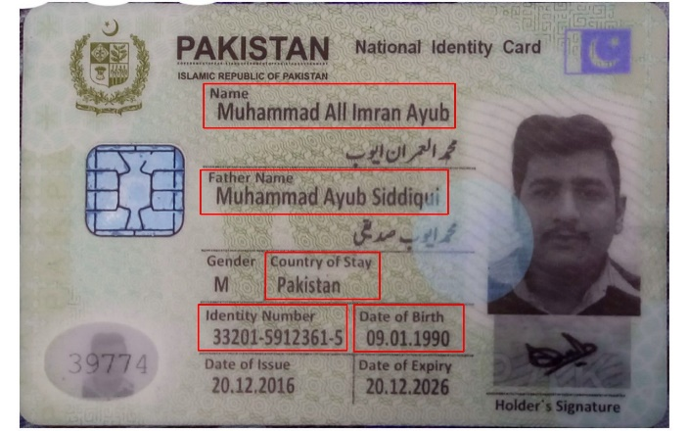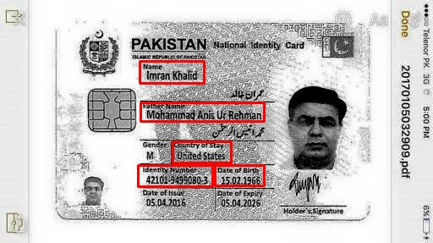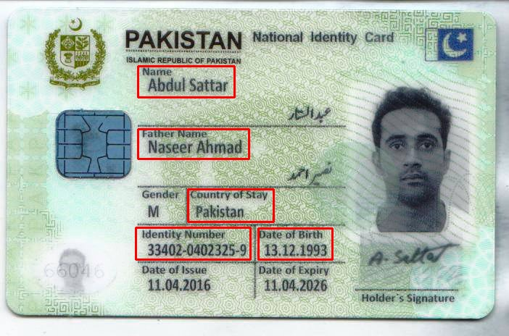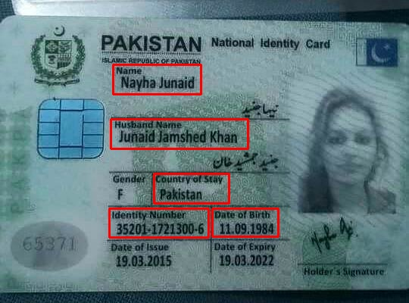

**UK License**

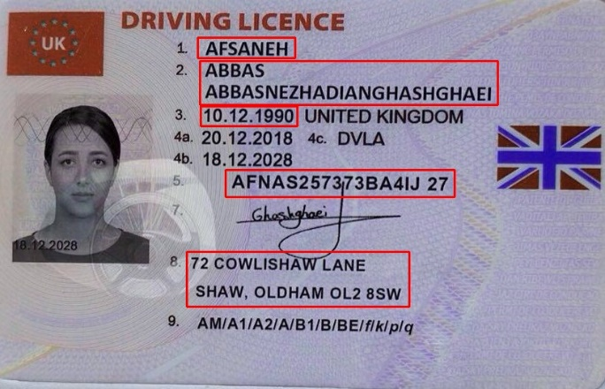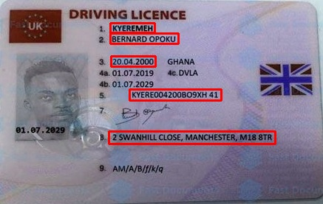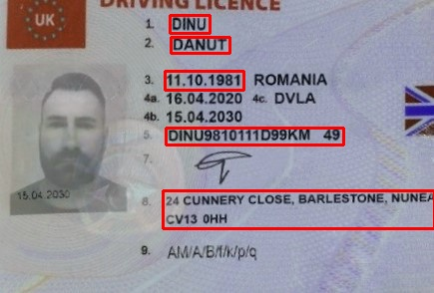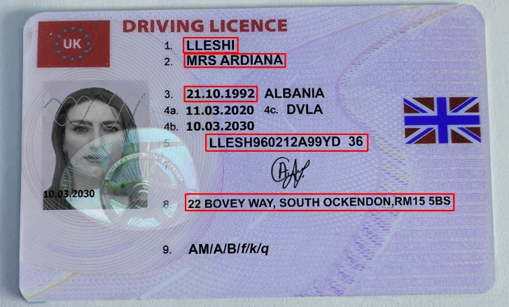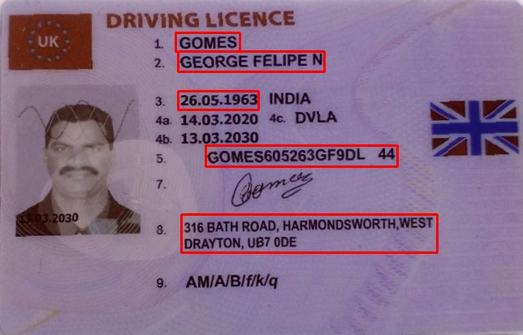

**Augmentation**

To augment the annotated images, we used BBAug, which is a python package built on top of the image augmentations package imgaug. It has a total of four policies, all of which contain sub-policies, which are collections of augmentations. For example, a sub-policy would look like:

*sub_policy = [('translation', 0.5, 1), ('rotation', 1.0, 9)]*

And, a policy would be:

*policies = [*

*[('translation', 0.5, 1), ('rotation', 1.0, 9)],*

*[('colour', 0.5, 1), ('cutout', 1.0, 9)],*

*[('rotation', 0.5, 1), ('solarize', 1.0, 9)]*

*]*

We used the **policy set version two**, which has been detailed in its finding papers in the following images:

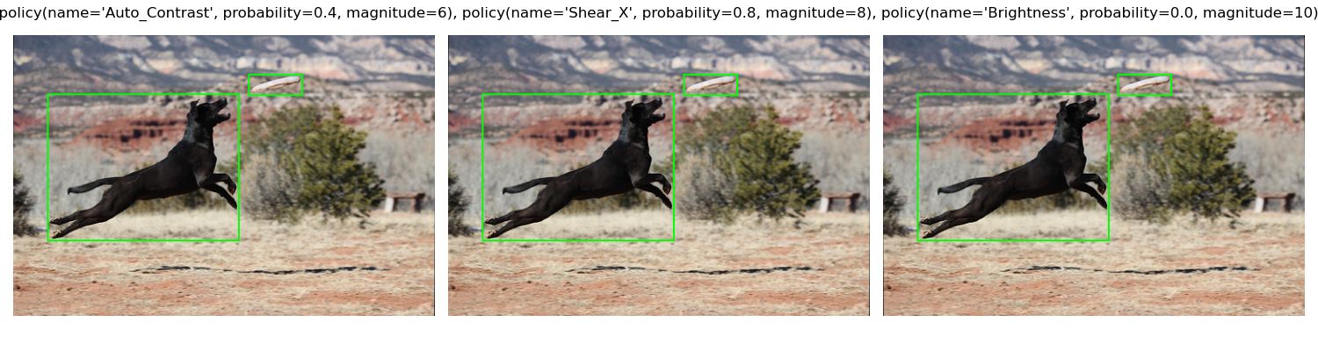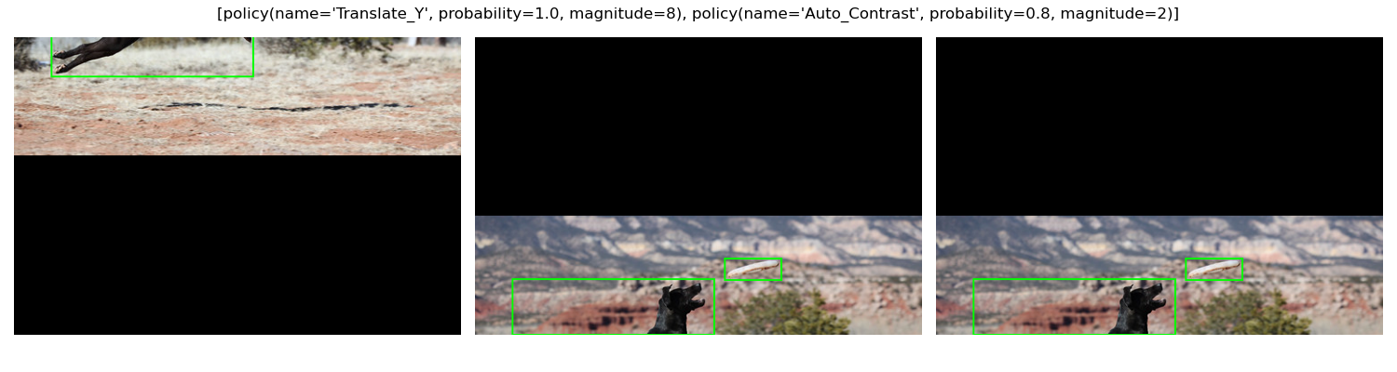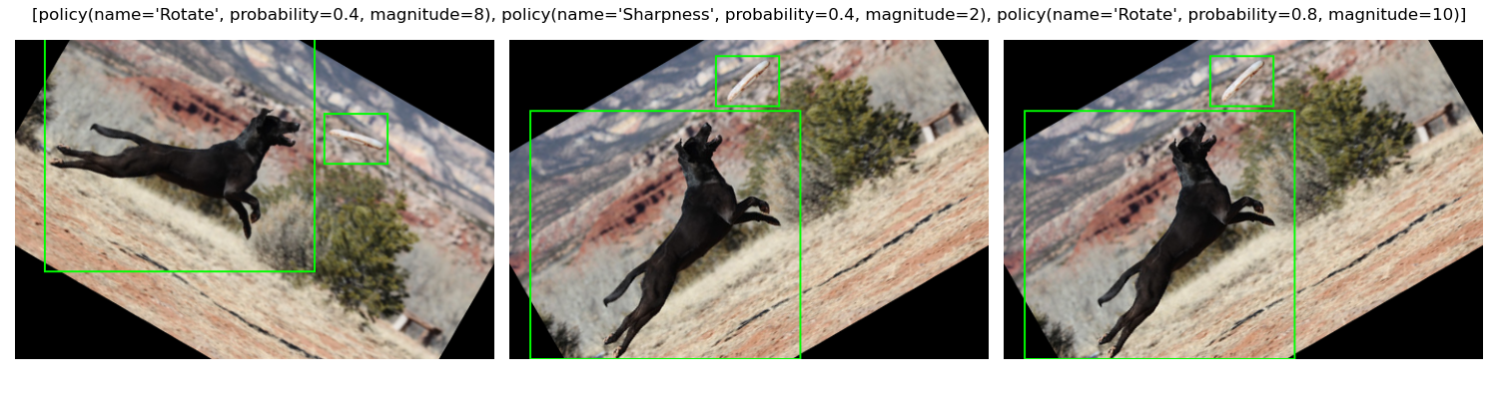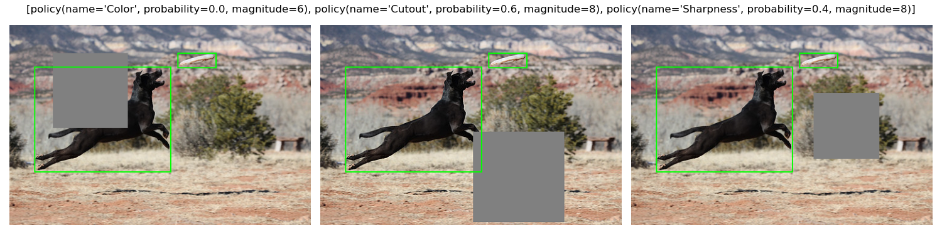

The augmentation is being done through the following techniques:

* Auto-contrast
* Brightness adjustment
* Translation of either X/Y coordinates
* Rotation
* Sharpness adjustment
* Cutout
* Sharpness adjustment

Using the following code snippet, I selected a random policy from the policy set each time augmenting the images:

*# select a random policy from the policy set*

*random_policy = policy_container.select_random_policy()*

However, it is important to note that the aforementioned techniques aren’t the only ones being made use of. To see a complete list of policies in policy set version two, run the following code:

*from bbaug.policies import policies_v2*

*print(policies_v3()) # Will list all the polices in version 2*

To read more about BBAug, visit this link: [harpalsahota/bbaug: Bounding box augmentations for Pytorch (github.com)](https://github.com/harpalsahota/bbaug)

**Augmented Images**

**Pak CNIC**

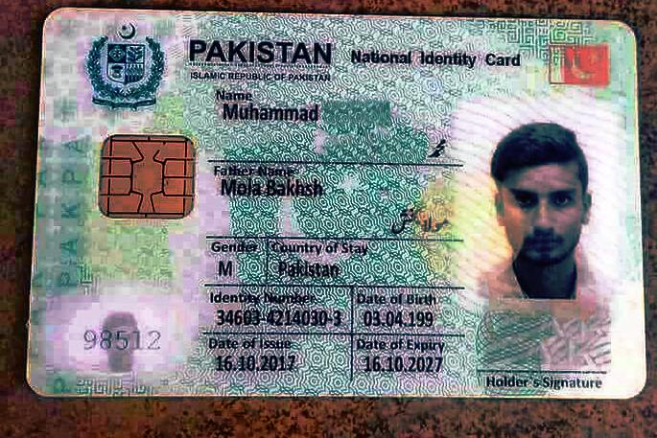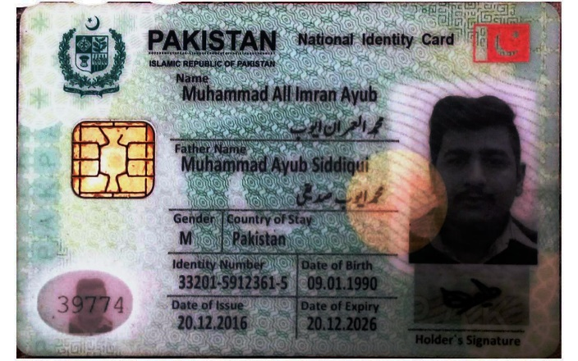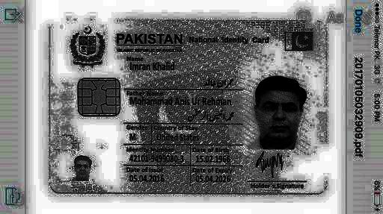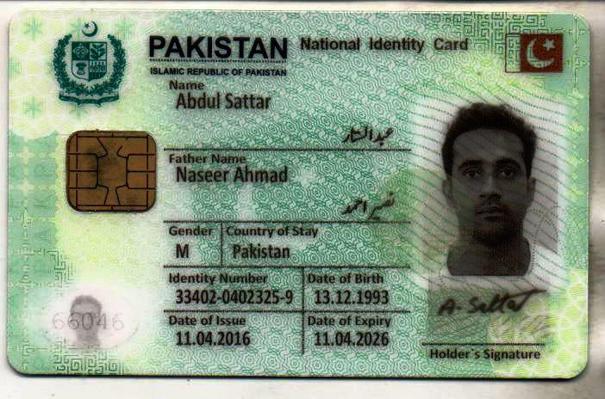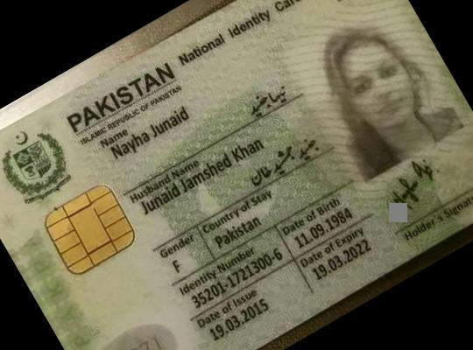

**UK License**

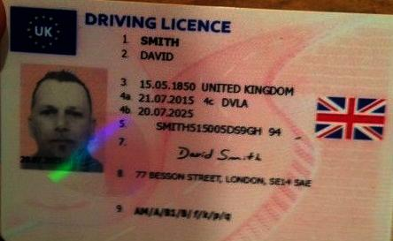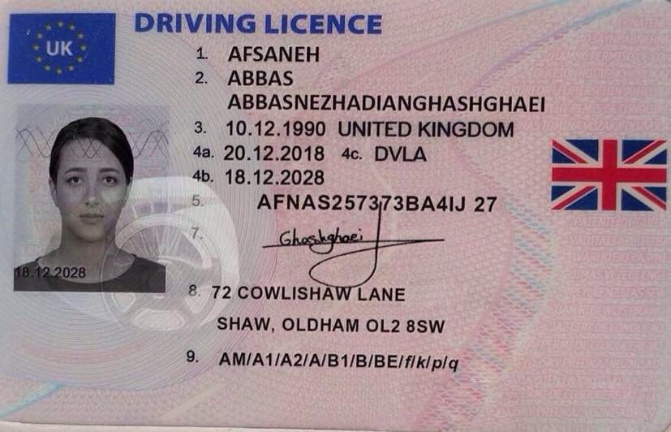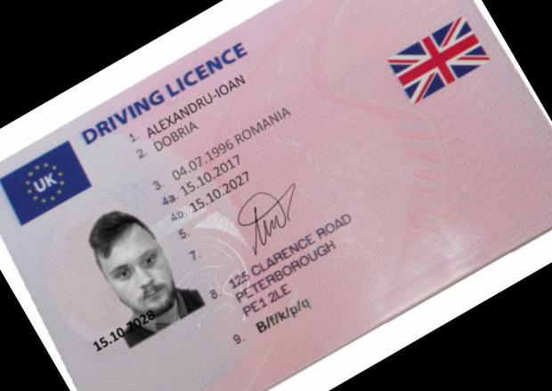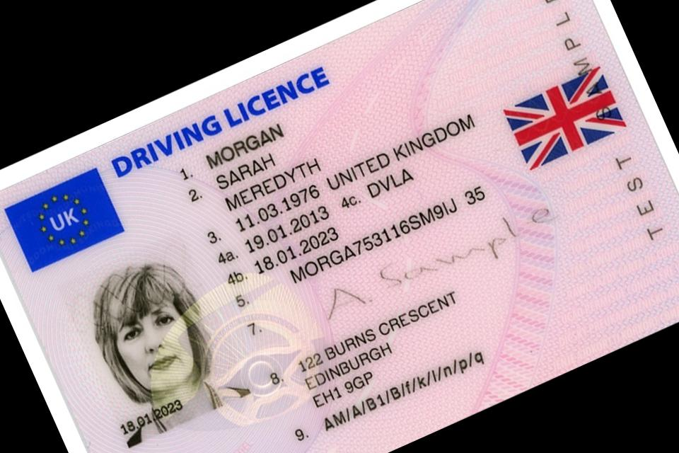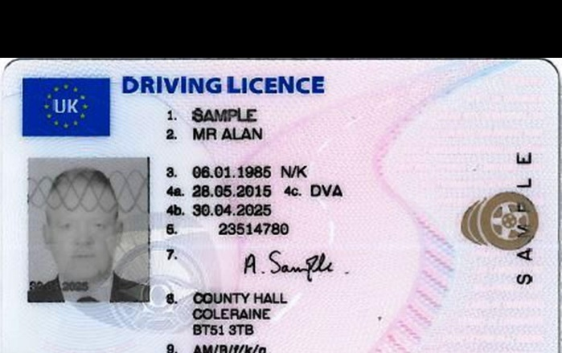

**Augmented Annotated Images**

**Pak CNIC**

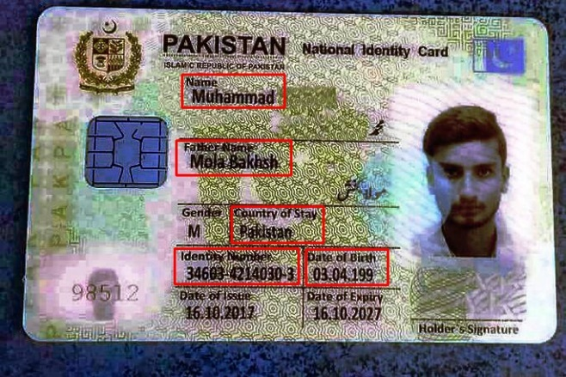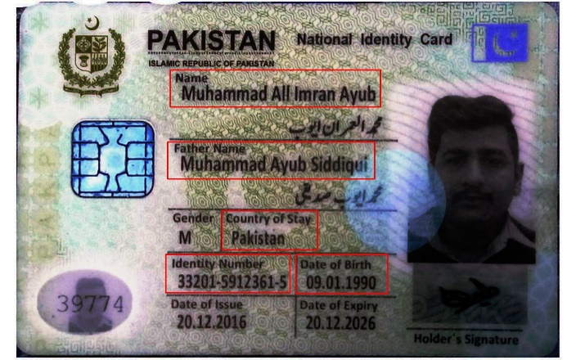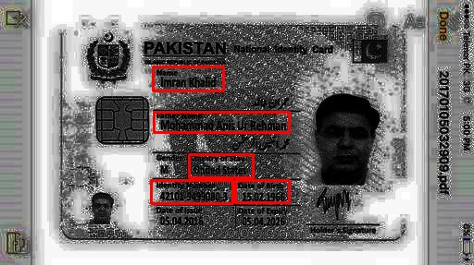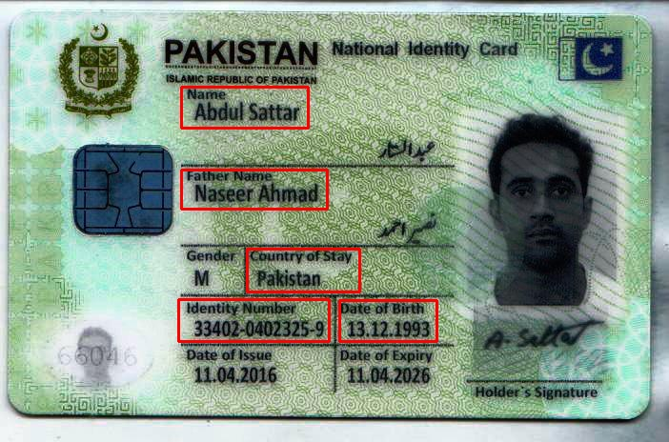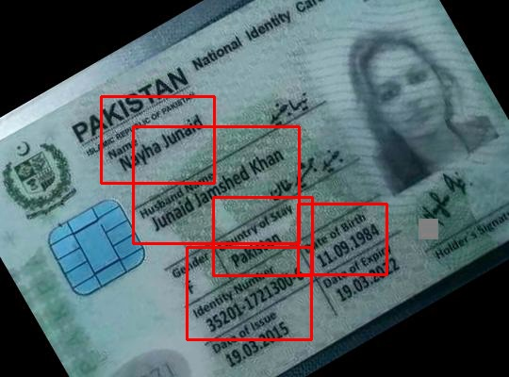

**UK License**

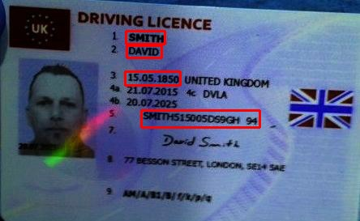 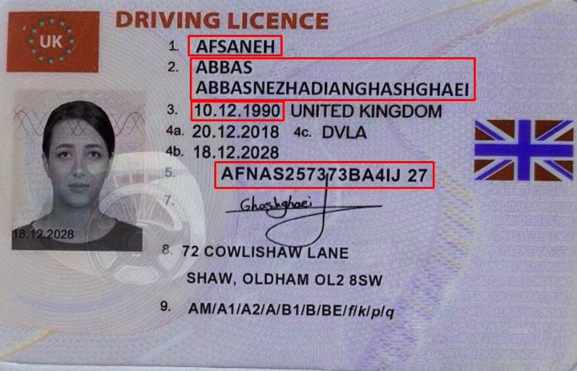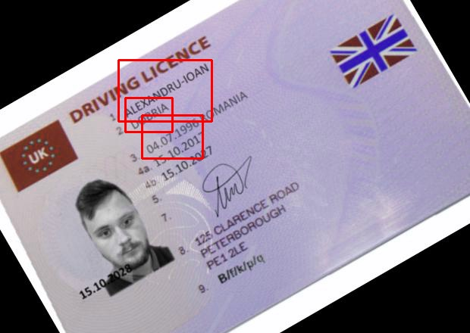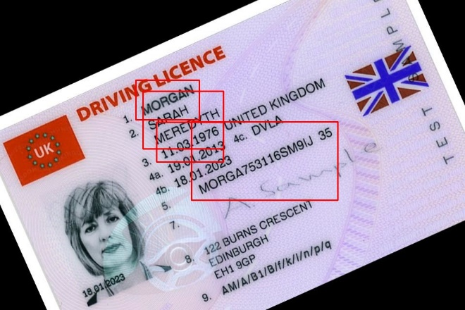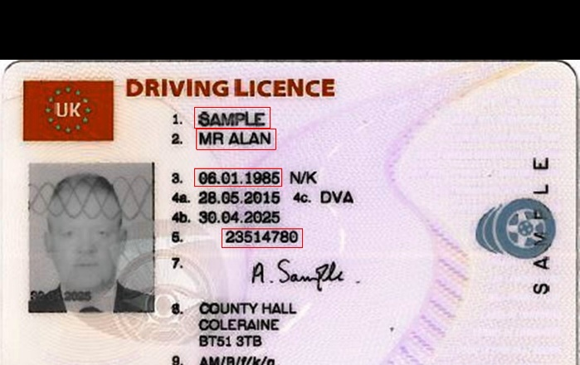

**Images Division**

**Pak CNIC Dataset:**

Total original images= 27

Augmented Images= 2422

80% for Training= 1960

20% for Testing= 489

**UK License Dataset:**

Total original images= 16

Augmented Images= 1334

80% for Training= 1080

20% for Testing= 254